**LOAN MANAGEMENT SYSTEM**

Project report

*submitted by*

Jagadeesh R - 2021506314

*In partial fulfilment for the Degree of*

**BACHELOR OF TECHNOLOGY**

***in***

**INFORMATION TECHNOLOGY**



DEPARTMENT OF INFORMATION TECHNOLOGY

MADRAS INSTITUTE OF TECHNOLOGY

ANNA UNIVERSITY

CHENNAI-600044

**LOAN MANAGEMENT SYSTEM**

**INTRODUCTION:**

The Loan Management System (LMS) presented in this abstract is a comprehensive solution designed to streamline and optimize the entire lifecycle of loans. It encompasses a user-friendly interface for seamless loan application, robust approval processes, efficient disbursement workflows, and intelligent repayment tracking mechanisms. The LMS acts as a centralized hub, providing real-time insights into loan statuses, payment histories, and risk assessments. With advanced features such as automated notifications, document management, and risk analysis tools, the system ensures accuracy, transparency, and compliance throughout the lending process.

# OBJECTIVES:

1. To provide good interaction & communication facilities between customers & administrator.
2. To provide interest rate and loan details at a mouse click.
3. Using with this system admin can find customer easily and it’s a paperless system, so workload is reduced.
4. Customer can apply for a loan and after approved it they can track their details from online.

# DATABASE SCHEMA:

borrowers(id, firstname, middlename,lastname, contact_no,address, email, tax_id, date_created);

loan_list(id, ref_no, loan_type_id, borrower_id, purpose, amount, plan_id, status, date_released, date_created);

loan_plan(id, months, interest_percentage, penalty_rate); loan_schedule(id, loan_id, date_due);

loan_types(id, type_name, description);

payments(id, loan_id, payee, amount, penalty_amount, overdue, date_created); users(id, doctor_id, name, address, contact, username, password, type);

# IO DATA:

**INPUT DATA:**

Customer details (name, address, mobile number, email, etc) and details regarding the loan they want to take (loan type, loan amount, monthly income, etc) is received as the input.

**OUTPUT DATA:**

Generated report on Loan Amount payment after verification of customer details from the admin side will be provided to that respective customer.

**SCHEMA DIAGRAM:**

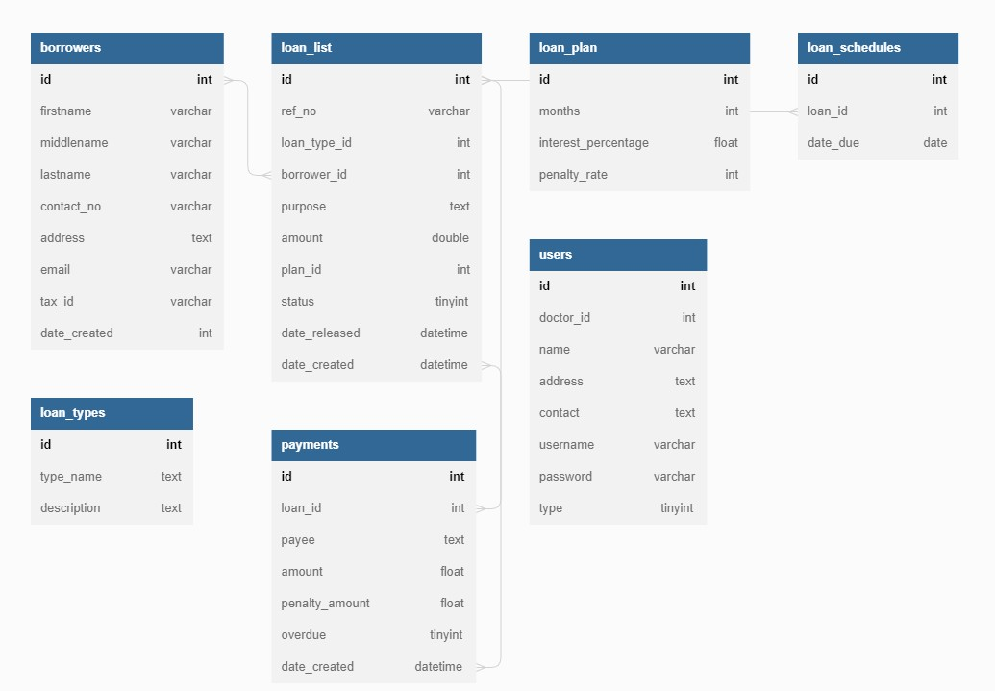

# PROGRAMMING LANGUAGES USED:

* 1. MY SQL
  2. PHP-SERVER SCRIPTING
  3. WEB-PAGE DESIGNING:
     1. HTML
     2. CSS
     3. JAVA SCRIPTING

**ENTITY RELATIONSHIP DIAGRAM:**

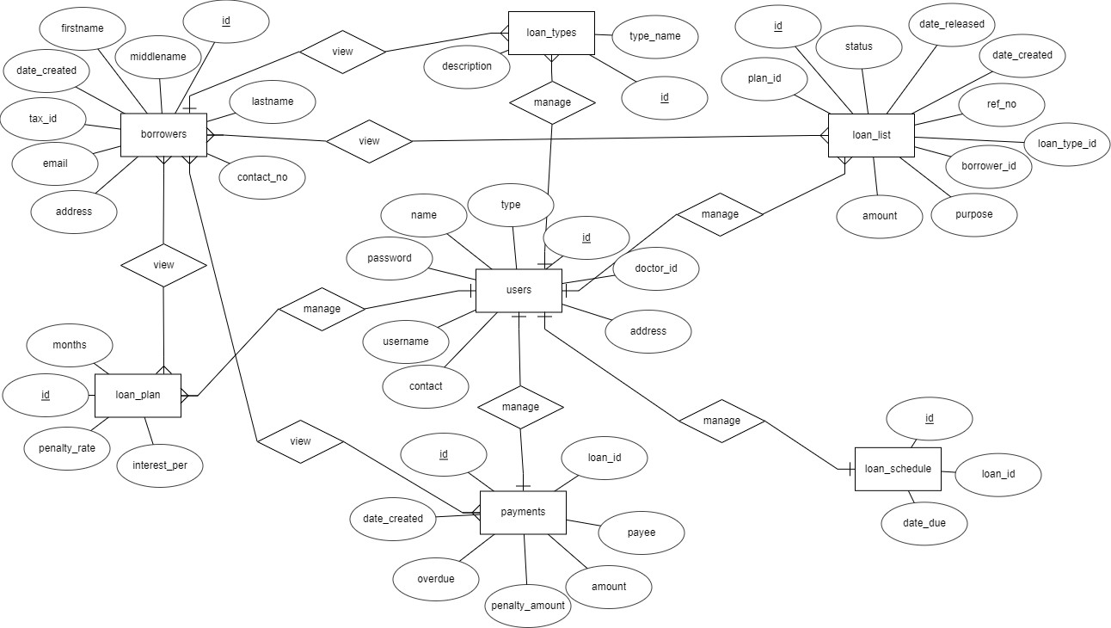

# USER INTERFACE DESIGN:

The UI for the database is designed using web development tools such as HTML5, CSS3 and bootstrap. Javascript is used for form validation and PHP – MySQL Connectivity is used to connect the database at the backend to the frontend.

# FUNCTIONALITIES OUTPUT SCREENSHOTS:

## LOGIN PAGE:

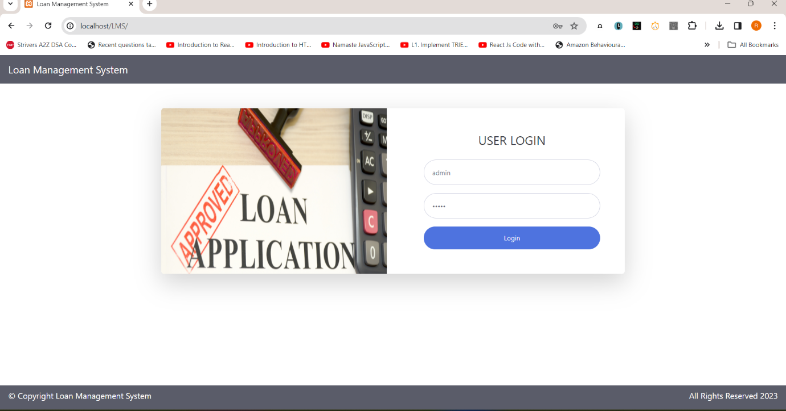

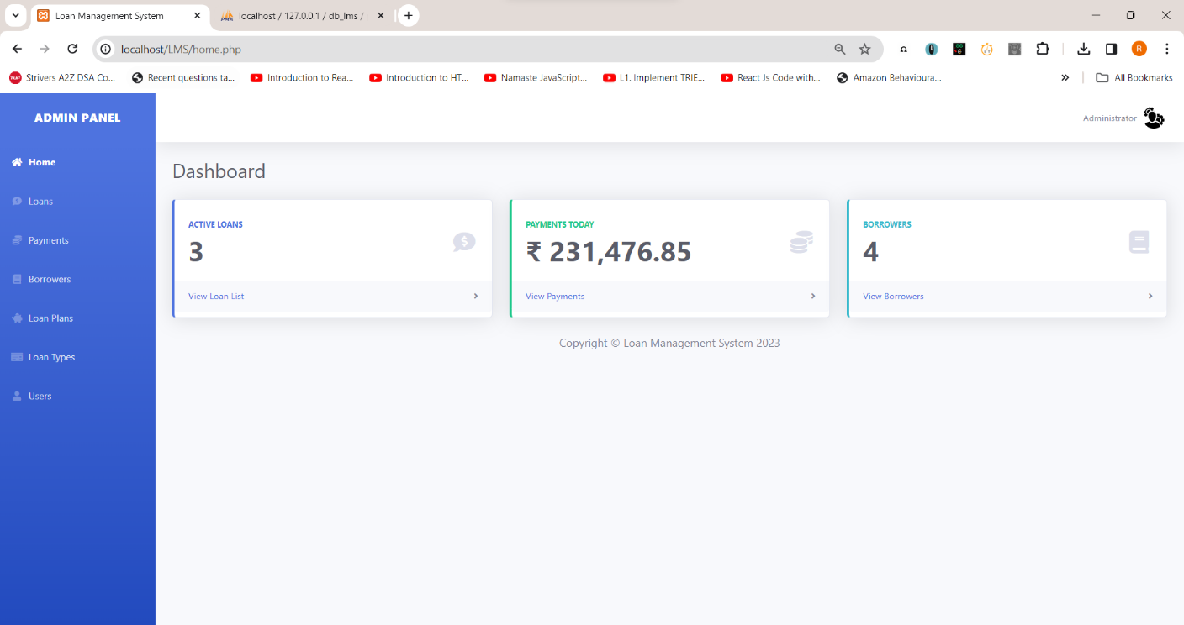

**ADDING LOAN TYPES:**

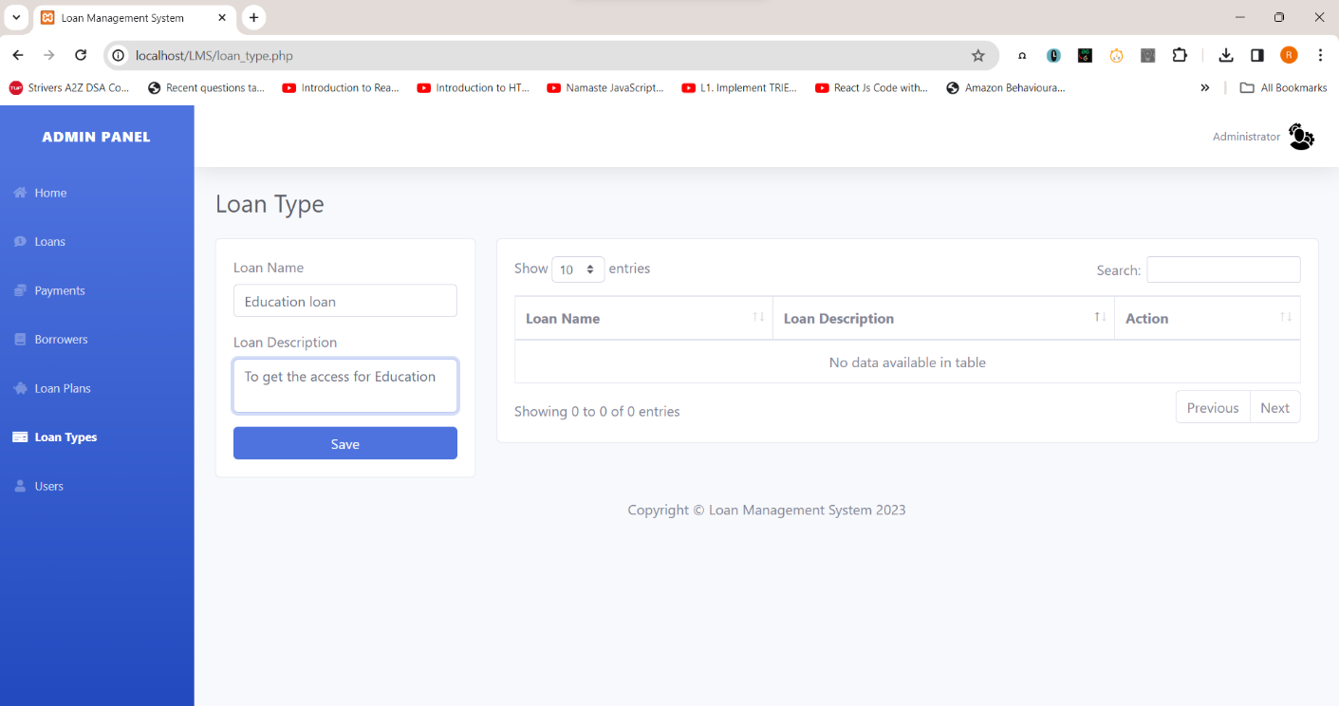

EDUCATIONAL LOAN TYPE IS SUCCESSFULLY ADDED.

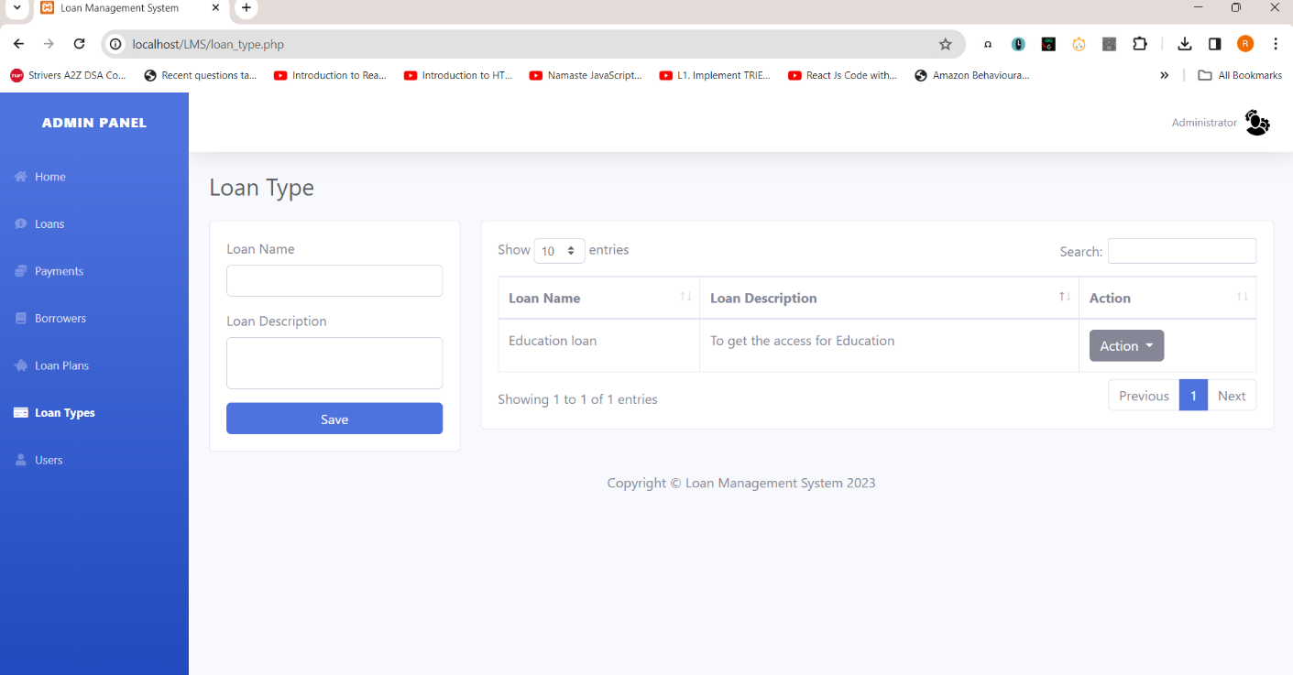

## ADDING LOAN PLANS:

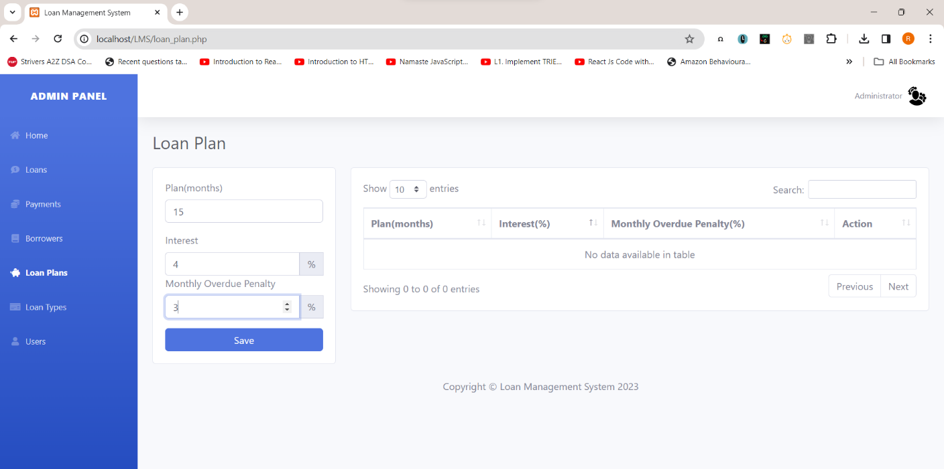

NEW LOAN PLAN IS SUCCESSFULLY ADDED.

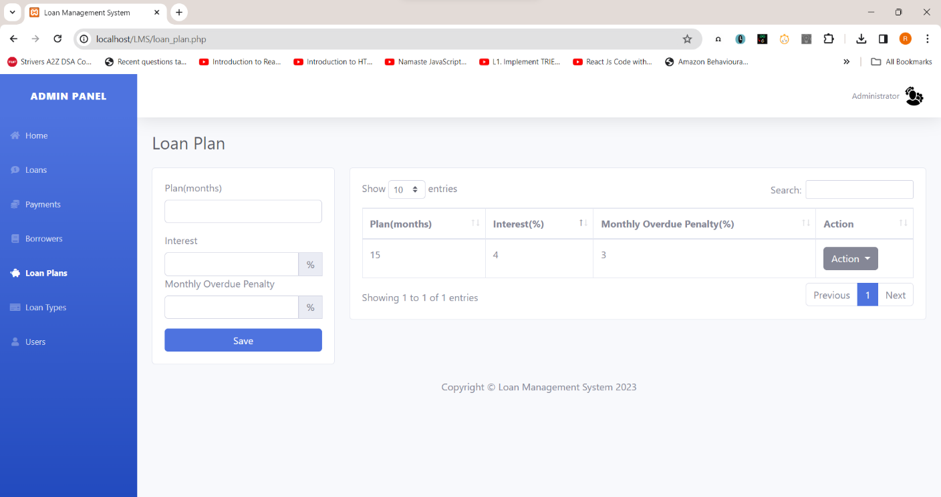

## ADDING NEW BORROWER:

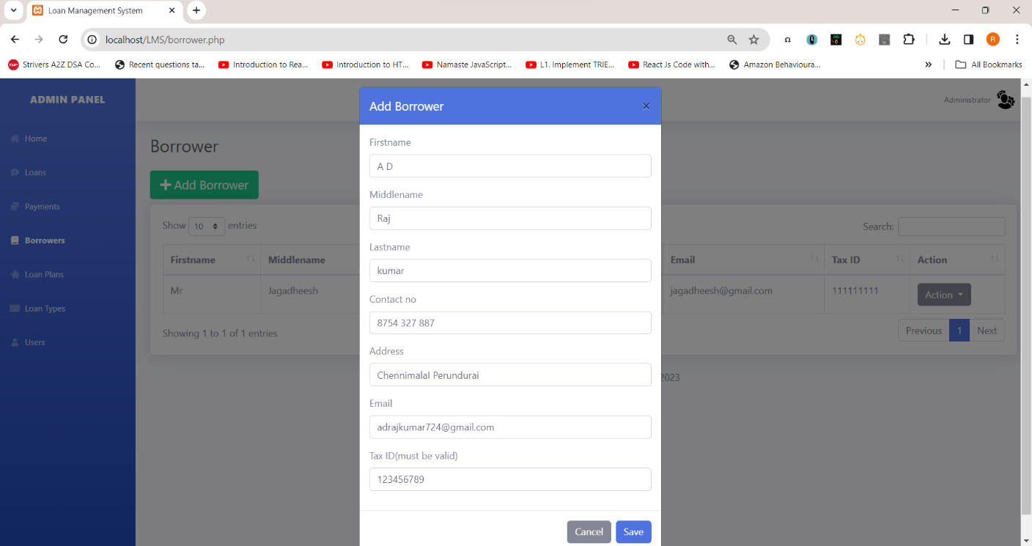



**LOAN PAGE:**

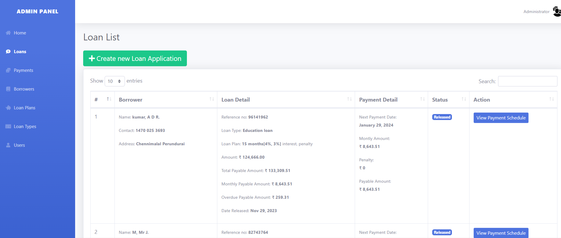

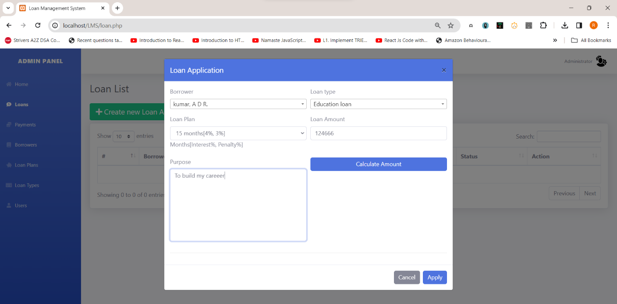

## CALCULATING THE AMOUNT:

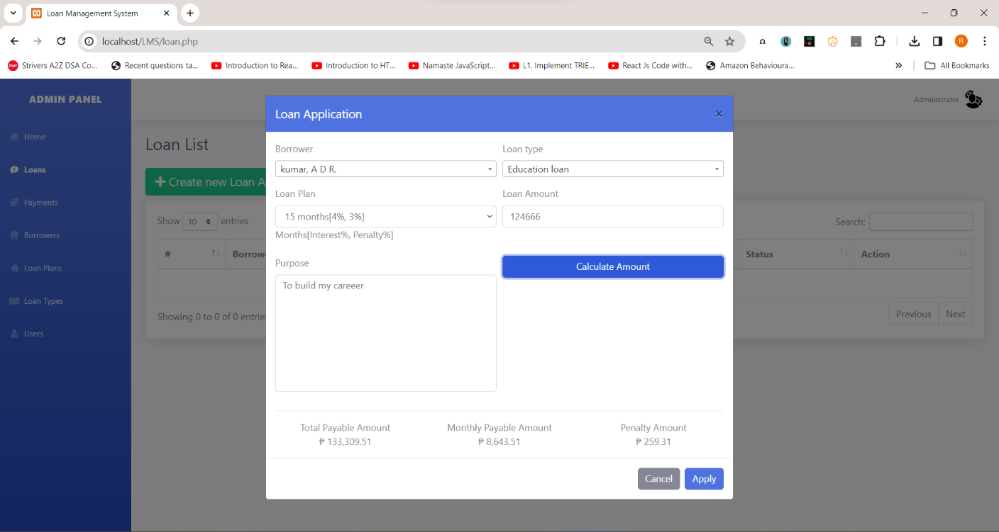

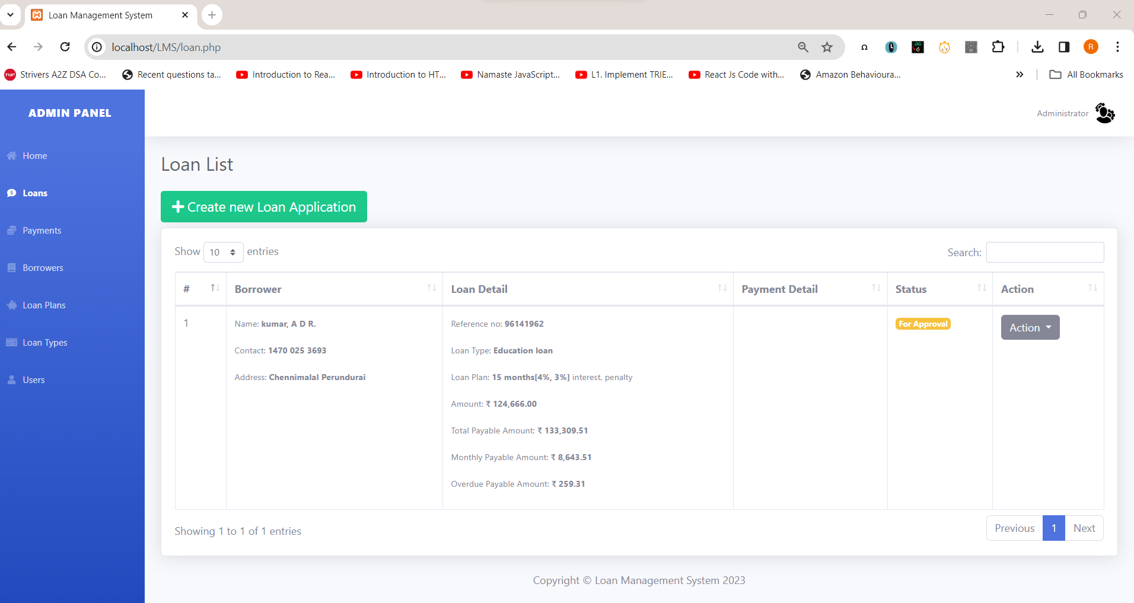

**APPROVING THE LOAN:**

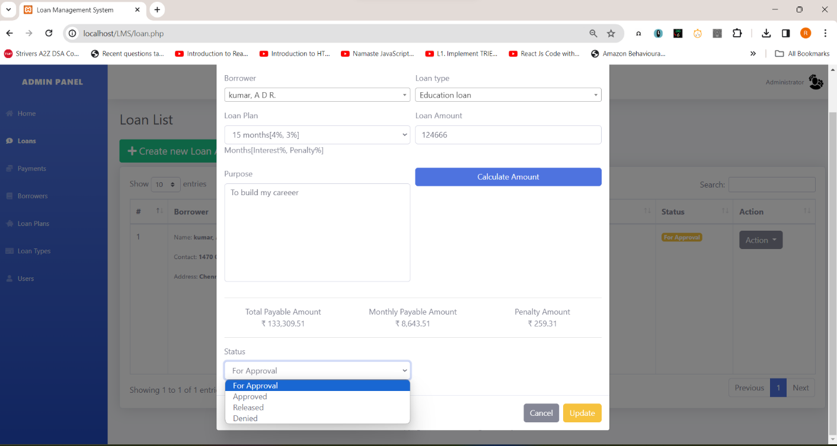

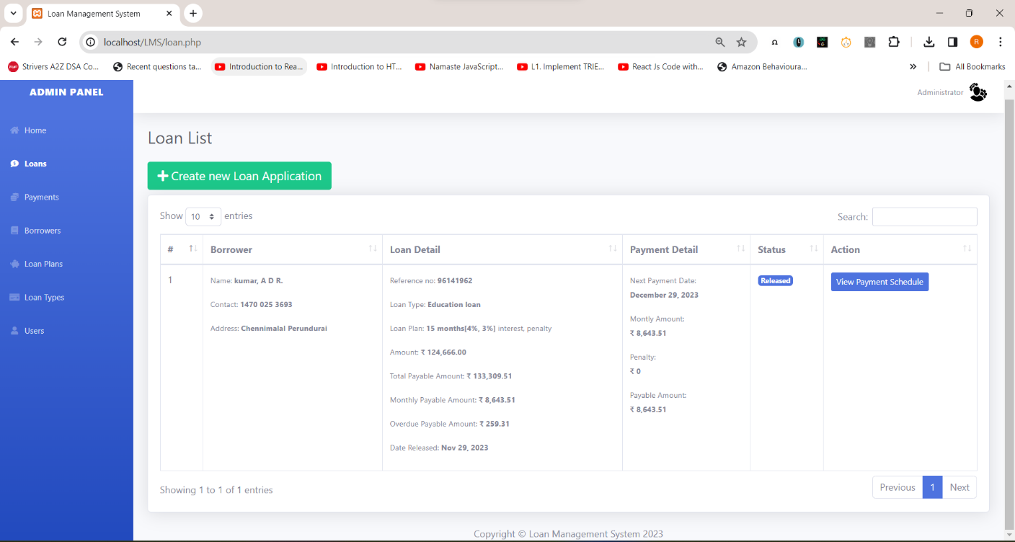

## PAYMENT PAGE:

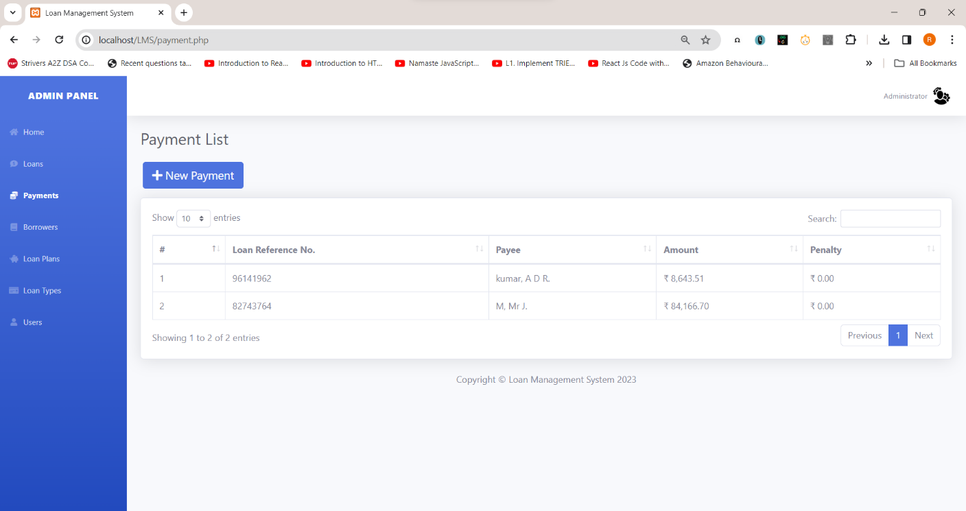

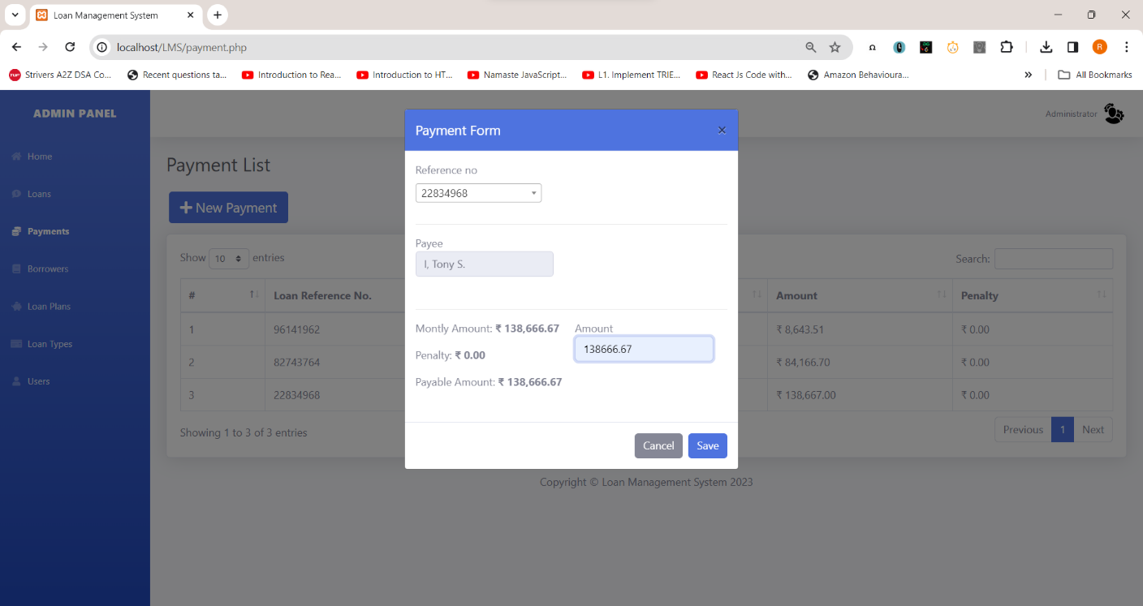

**AFTER CLICKING SAVE:**

PAYMENT IS SUCCESSFULLY ADDED.



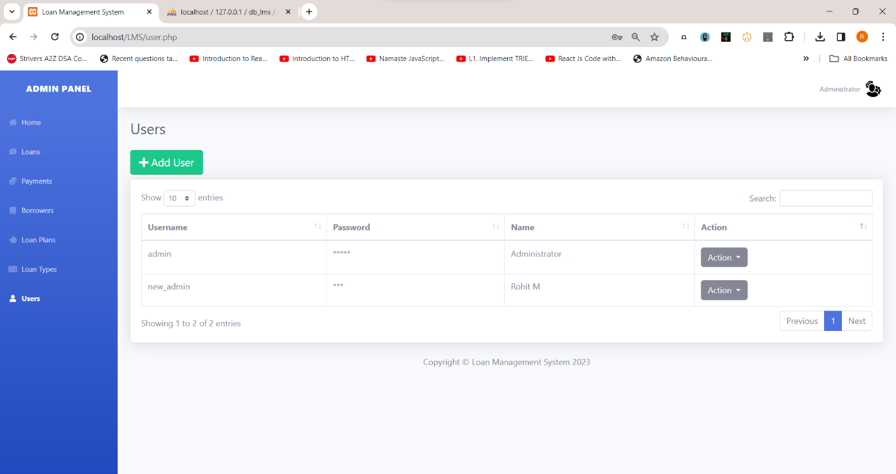

## ADDING NEW USER:

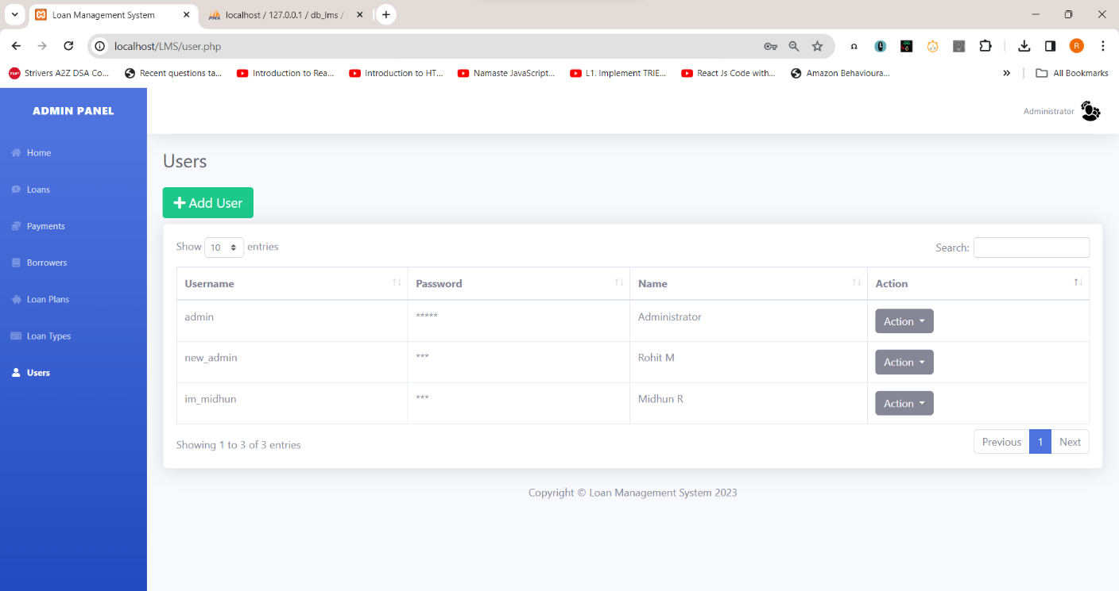



**RETURNING TO THE HOME PAGE:**

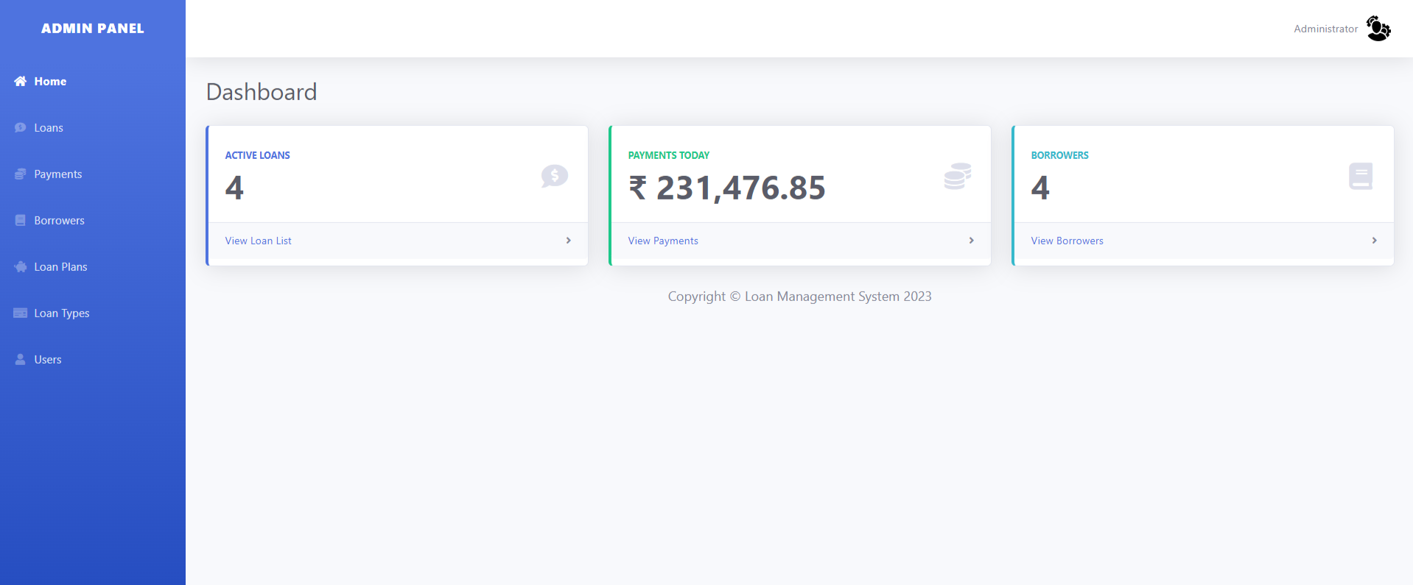

# CONCLUSION:

Thus, we have created the loan management system to manage the every stage of loan life cycle.

The Loan Management System (LMS) is a comprehensive, user-friendly solution designed to optimize the entire lifecycle of loans, from application to repayment. With its robust features and functionalities, the LMS provides significant benefits to both customers and administrators.

The well-structured database schema supports the system's functionality, providing a solid foundation for managing borrowers, loan plans, loan schedules, payments, and user information. By leveraging this schema, the LMS ensures data integrity and facilitates quick retrieval of information, thereby enhancing operational efficiency.

The LMS enhances interaction and communication between customers and administrators, provides real-time insights, and promotes a paperless environment, making it a valuable asset for any lending institution.